4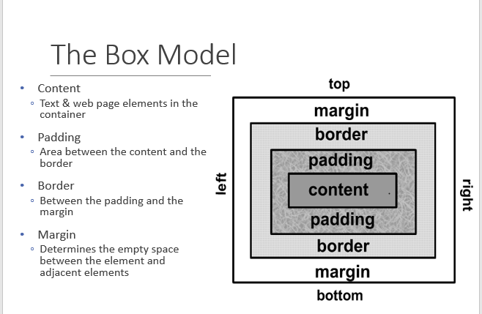

Navigation element tables

|  |  |  |
| --- | --- | --- |
| Name Of Element | Description and Link | Included in pages |
| Core Pages (Main) | Hierarchical navigation bar with the following elements and indentations:   * Home (target: index.html)   (Block Post)Kids (target: kids.html)  Our Team(target: contactus.html)  Donate Now (target: donation.html)  Explore History( target: explore.html)  Request for Books( target: requestforbooks.html)  Morenike’s Corner(target: morenikescorner.html )  Please make donation(target: donation.html)  Become a Member Tab(target: memebership.html)   * About Us (target: aboutus.html) * Donation (target: donation.html) * Membership(target: membership.html)   Media Link: form   * Play Time (target: plattime.html)   Media Link: Youtube   * My History, Your Story (target: Links .html) * Morenike's Corner (target:Morenike's Corner.html)   Audio link: (target: expression1.mp3)   * Contact Us (target: contactus.html) | All |
| Media link list | Text-based list containing the links: Next button (target: Next html nav)  cd (target: cd.html)  book (target: book.html) |  |
| Footer | Become A member(target: donation.html)  Donation(target:donation.html) | All pages |
| Footer | Contact Us (target: contactus.html) | All pages |